Comments on meeting 8 September 2011
BRIGHTON GROVE
We remain unconvinced that parking (other than blue badge) must be provided at the site.
We heard at the meeting that there is vehicle access to every plot: a one-way single lane system is in operation on site for dropping-off (people, material). After doing so, we believe, parking can then be sought elsewhere in the vicinity, but is not required on Brighton Grove.
We urge the council to see the bigger picture.
We also fear that further anti-cycling precedents are set and best practice is ignored: we know that good cycling provision happens when the design favours the bicycle over the motorcar by giving road space to cycling. This is not the case with the council’s current proposal. It could be done by doing away with the currently proposed on-road car parking (we are not satisfied with the current ad-hoc method of determining car parking spaces, more thought and investigation should go into that, if not this time at this site, then the next scheme).
We suggest that blue badge parking (proposed three spaces) can be coordinated with the skip removal in the ‘grasscreted area’. Access to the skips will be regular (easily coordinated with blue badge holders) and minimal (we have asked on numerous occasions for the council to confirm the frequency).
This practice of giving space to cycling has always proofed politically difficult in the past, as it’s seen by councillors (seeking re-election from a presumed car-centric electorate) to “take away from the car and people’s freedom”. This may well be one if not thE reason why cycling provision has stagnated in recent years in Newcastle: all easily available road space has now been allocated to cycling (sometimes well, sometimes not so well) and we have now reached a point where difficult decisions have to be made. Crossroads: the council must stop providing solely for the driver, and start to fully embrace the bicycle as a mode of transport.
As the proposal is likely to go ahead with the on-road car parking, we will make some improvement suggestions to the current scheme. This does not affect our part-objection: we are still objecting to the scheme on ideological grounds.
In a general way, we ask the council to assess current car parking provision at their allotment sites and cross-relate it to this site to make a better-informed decision. (We ask the council to draw up a strategy for car parking provision at allotments. We believe allotments should be local resource and should be for local people, locally accessible.)

We would welcome the council to draw up revised plans. And for an opportunity to comment on these plans.

Scheme specific comments
1. Transitions: Run-up and run-off should be design for smoothness and ease of use. Current design is woefully lacking and was disappointing to see. The transitions should be kerbless, sufficiently long and the curve should be given large radii. The run-up/down could be designed as depicted below, making the curviness and height change less obvious to the user. Run-up/down could be vertical rather than on a slant (which can be slippery in winter if too sudden or too oblique). The fast commuter speed (downhill) should be taken into account.
Photograph 1 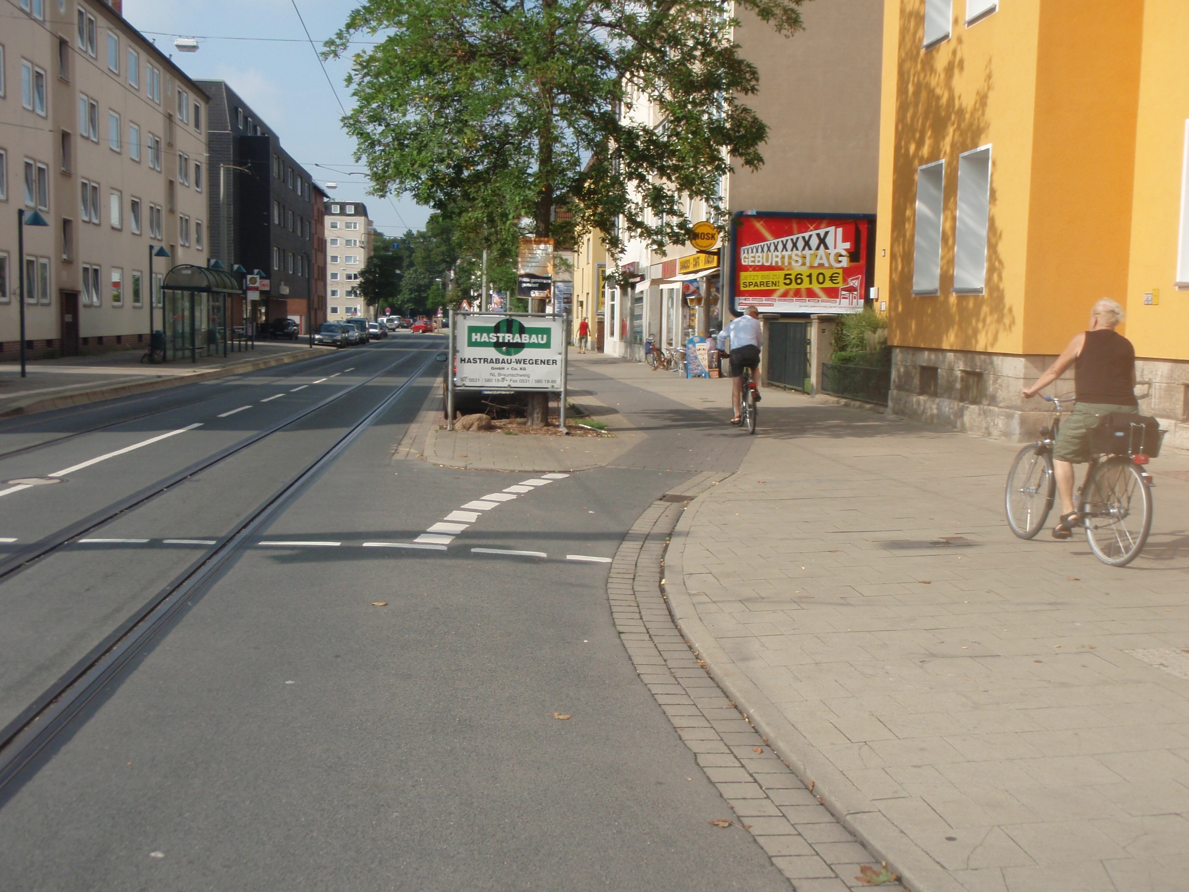

2. Shared path: Mixing modes in a tight space of min width 2.5 metres is ill-advised and would hinder, not encourage, cycling. The conflict created by the current proposal is not acceptable, nor fair to either user. We propose that a 1.5 metre wide cycle path must be clearly marked on the pavement to distinguish from the walking area. This renders the footpath 1 metre wide (minimum) which should be sufficient as there is not much foot traffic, we heard at the meeting.
3. Car parking provision: As outlined above we do not believe car parking is required, however, if some parking is installed we urge the council that the decision to provide car parking is driven by what can be safely provided taking into account all users: car parking should hence not go beyond the site access and could possibly be provided from the site access south-westwards to the next access point which is the skip area. It is also essential that good visibility splays are provided for cycling and walking safety. Current visibility splays seem insufficient.
4. Allotment access: It is important to provide cycle continuity and this should include the allotment access point. Pedestrian and cycle continuity could be provided by a raised table and showing priority (or presence) by marking or material as this example demonstrates below depicting a property access. Provision of good sightlines are essential here too. If not already in place, a sufficient ‘neck-down’ (to minimise the turning speed) must be provided.
Photograph 2
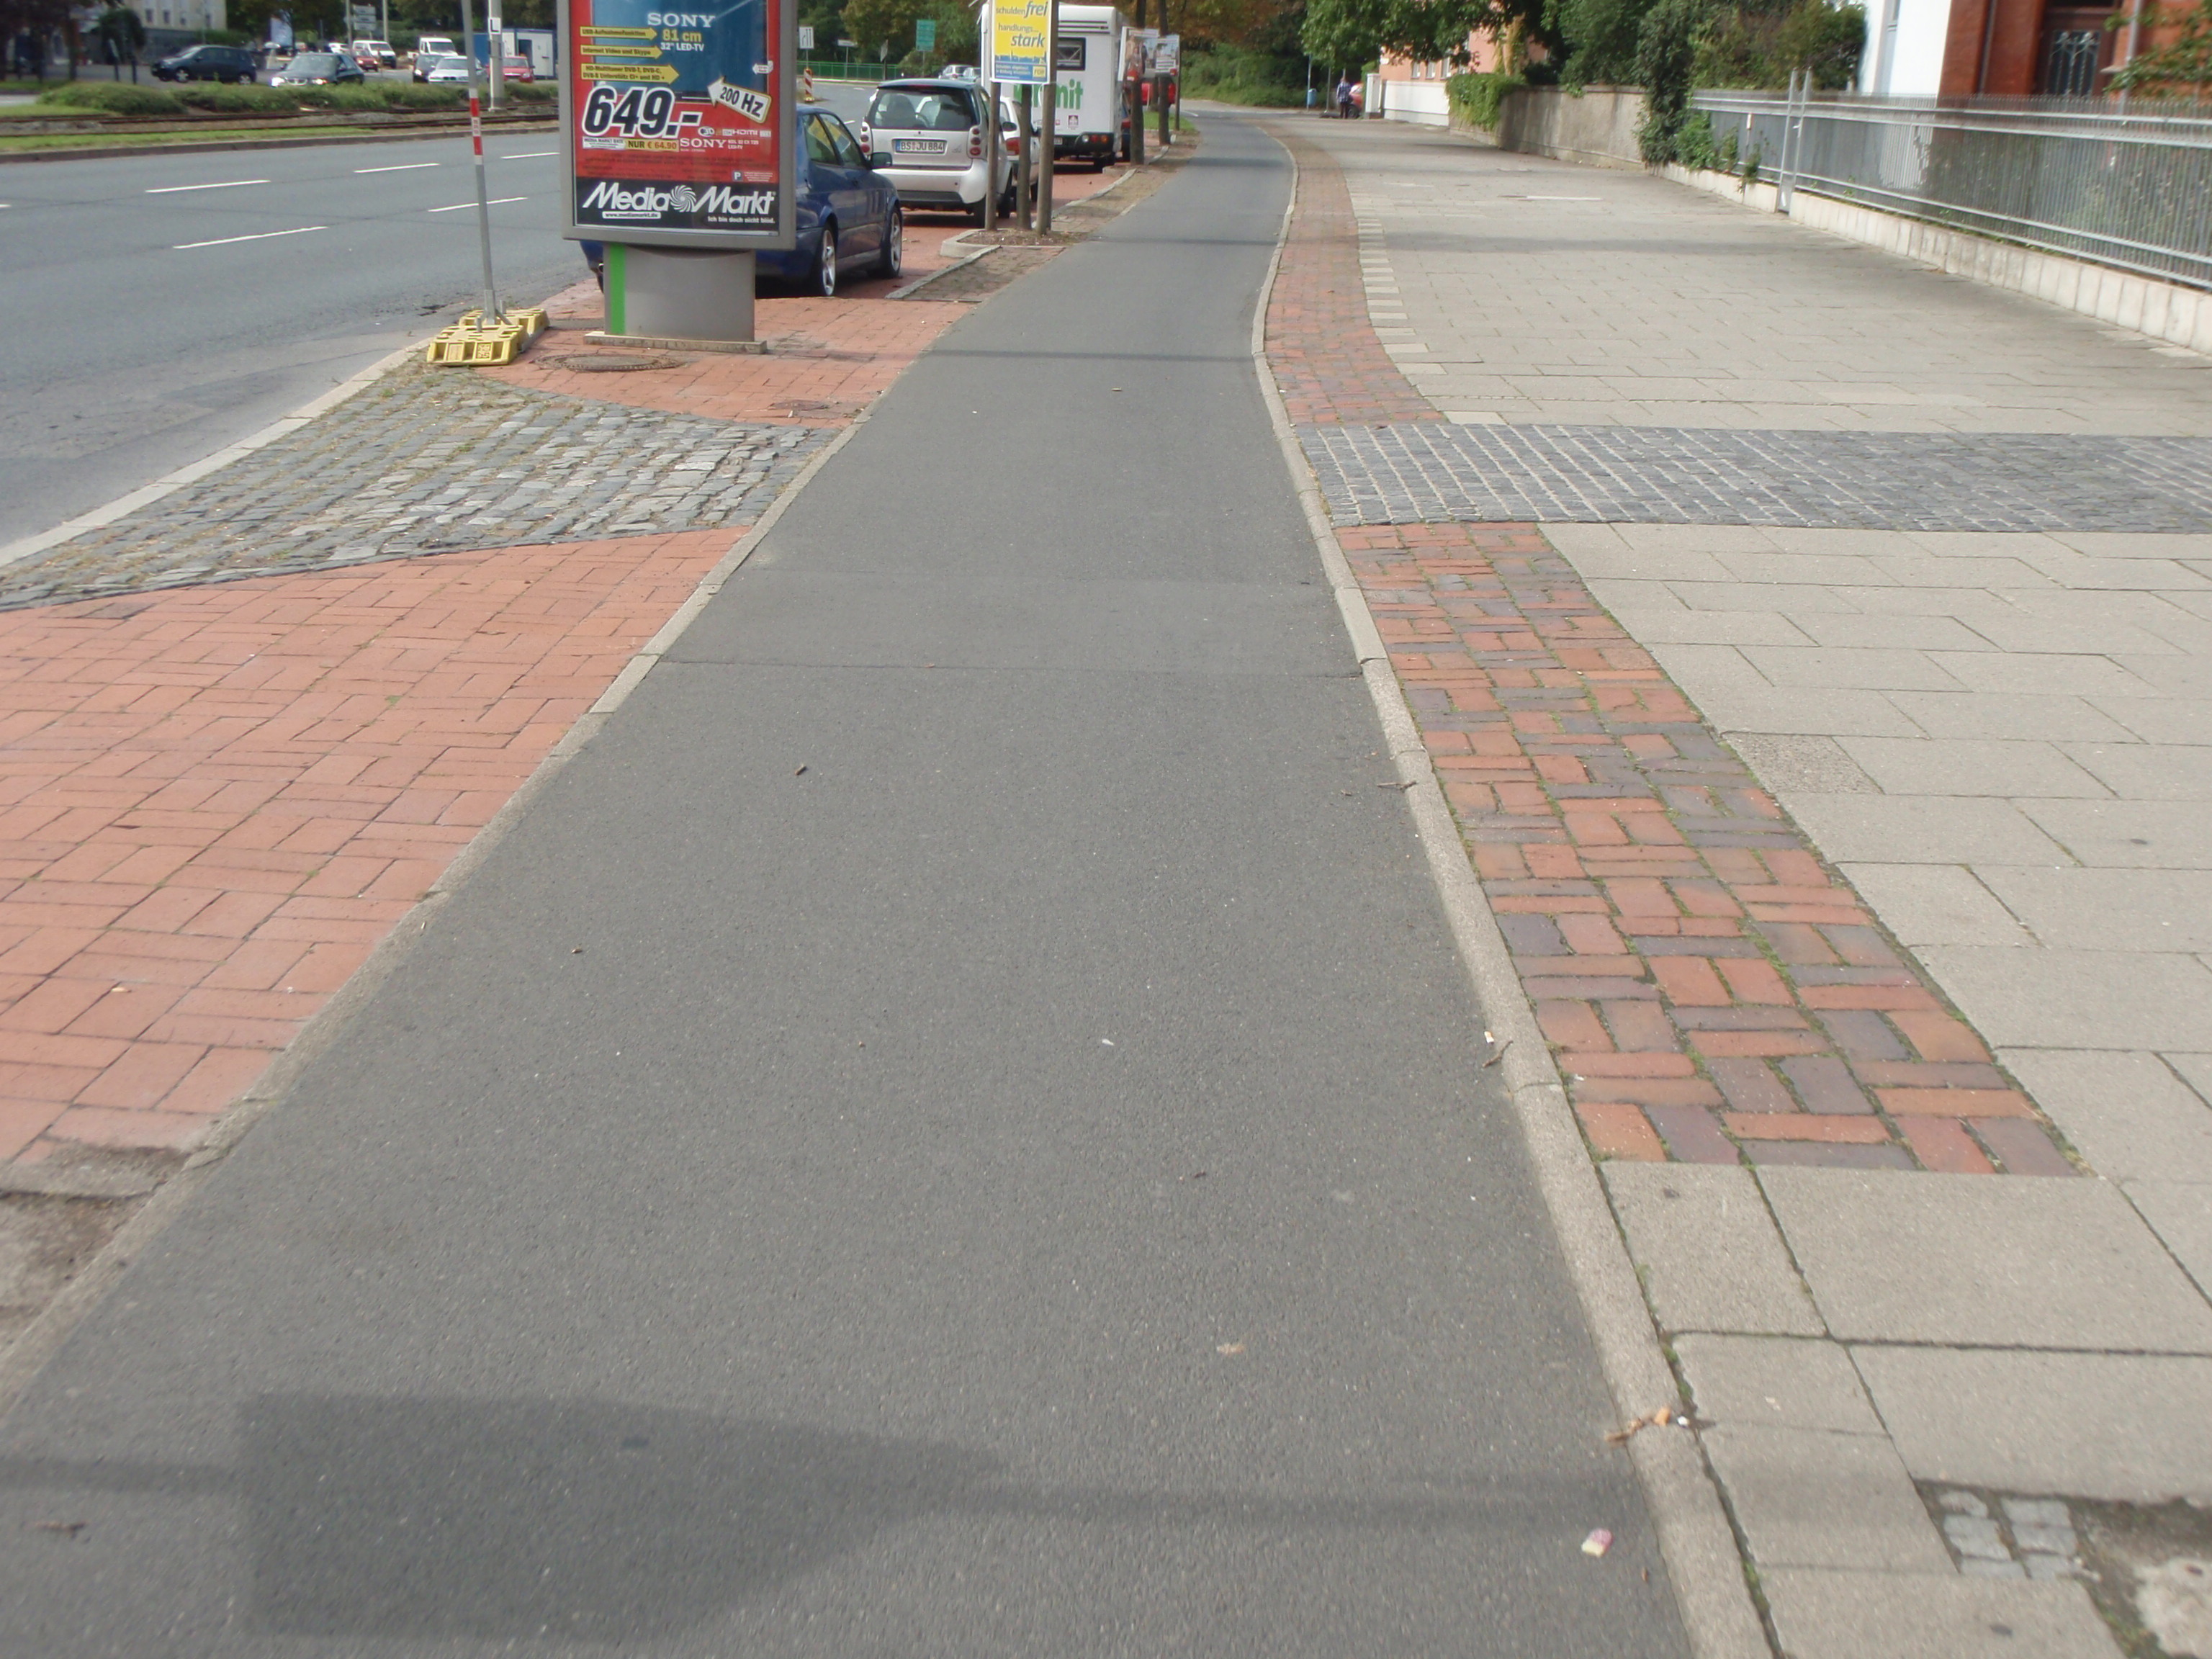

5. Use half-width DYL (as suggested previously).
6. A 0.5m door buffer zone should be included in the design as suggested by best practice.
7. In summary, at the “car parking cross-section”, space is allocated like this
1m min | 1.5m | <kerb> | 0.5m  + | 1.8m | 2.75m (no centre line) | 2.75m | 1.5m | <kerb> | Foot  way
2.5m min |  |  | Road space 9.3m |  |  |  |  |  | As is
walk | Cycle  downhill |  | Door buffer | Car park | Car | Car | Cycle  uphill |  | walk
+ where road space is more that 9.3m increase buffer zone

